**Stage Zero/Eight Restoration Road Trip: April 2024**

Ray J. White, Owner, Trout Habitat Specialists, Edmonds, WA [rw@seanet.com](mailto:rw@seanet.com)

Tracy Hames, Executive Director, Wisconsin Wetlands Association [tracy.hames@wisconsinwetlands.org](http://tracy.hames@wisconsinwetlands.org)

Photo’s by Ray White and Tracy Hames

This Spring (April 2024), we toured a number of [Stage Zero](http://stagezeroriverrestoration.com/index.html) restoration projects across Central Oregon. The tour was coordinated by [Colin Thorne](https://en.wikipedia.org/wiki/Colin_Thorne) along with diverse interdisciplinary groups of folks involved in the work being conducted at each location. Ray’s interest was in learning about the novel river restoration approaches being developed in Oregon and applied in a variety of situations. Tracy’s interest was in seeing how Stage Zero concepts are being used in real-world floodplain restoration efforts, with an eye on lessons learned in Oregon that may be useful in promoting restoration of adversely impacted streams to their Stage Zero condition in Wisconsin. Four days on the road with Colin certainly gave us much to consider. We covered a wide range of fluvial environments, starting near the southern Oregon coast, and working our way east, through the Cascades and into the interior Columbia Basin.

**Day 1: Fivemile and Bell Creeks, near Florence, OR (see Figures 1-6).** On day 1, we were introduced to Paul Burns, USFS fisheries biologist with the [Sinslaw National Forest](https://www.fs.usda.gov/siuslaw) and USFS ‘Enterprise Team’ <https://www.fs.usda.gov/enterprise/skills-and-services.php>. Paul is a transplanted Wisconsinite and life-long Packers fan. He explained how [Fivemile and Bell Creeks](https://www.fs.usda.gov/detail/siuslaw/landmanagement/resourcemanagement/?cid=stelprdb5383646), like so many other creeks across the continent, have suffered the effects of watershed disturbance over 100+ years. Forest clearcutting buried the channels and floodplains in ‘legacy’ sediment, and channel ditching concentrated flood flows, causing channel incision and floodplain disconnection. The results were creeks out of balance, vulnerable to flashy runoff, and suffering from reduced morphological complexity and biodiversity. Restoration to Stage Zero involved removing post-European development legacy sediments from the floodplain and using it to fill in the ditched channel. In areas infested with reed canary grass, the sod was carefully flipped upside down and placed in the bottom of the ditch before it was filled. Filling artificial ditches has allowed the creeks to re-engage with their pre-disturbance floodplains and develop their own courses and anabranches as they spread out and as vegetation and beavers help finish the job.

**Day 2: Middle McKenzie River at Finn Rock, Deer Creek, & South Fork McKenzie Projects (see Figure 7 – 11).** On Day 2 we saw how Stage Eight and Zero concepts can be applied in much larger rivers. We began the day meeting with an array of partners involved in this multi-phased effort. These included representatives from the USFS Enterprise Team and Willamette national Forest (<https://www.fs.usda.gov/willamette>), [McKenzie River Watershed Council](https://www.mckenziewc.org/), [McKenzie River Trust](https://mckenzieriver.org/), Oregon Watershed Enhancement Board (<https://www.oregon.gov/oweb/pages/index.aspx>), and Oregon Department of Fish and Wildlife (<https://www.dfw.state.or.us/>). It was immediately clear that the members of this partnership were proud of what they’ve accomplished (so far) and excited about future restoration possibilities for expanding application of these concepts into other areas.

Prior to restoration, the situation at Finn Rock on the McKenzie River resembled what we saw and heard about on Day 1. An originally complex, broad, multi-channeled floodplain had been altered by decades of human actions. Combined effects of upper watershed disturbance, vegetation removal and alteration, channel simplification to improve navigation, levee building, and other actions had simplified this reach of the mainstem river. The results included a much drier river corridor, loss of wetland and multi-channel habitats, warmer summer flows, higher-energy flood flows, channel incision, and great loss in biodiversity/productivity. Restoration involved, (i) removing post-development deposition to lower a portion of the former floodplain and reconnect it to the incised mainstream (generally referred to as Stage 8 in the Stream Evolution Model), (ii) using the removed material to fill a large, abandoned gravel-pit and several incised side-channels, (iii) placing massive amounts of large wood throughout the project area, and (iv) allowing natural floodplain processes and vegetation (partly from extensive plantings) to do the rest. The result is a multi-channel river corridor, an increase in the wetted perimeter, and a rough and messy floodplain that is reconnected to the river at base flow (<https://mckenzieriver.org/finn-rock-restoration-complete/>).

Viewing nearby Deer Creek introduced us to a situation requiring a different approach to restoration. The reach of Deer Creek (a steep tributary to the McKenzie River) we visited experienced logging and channelization followed by installation and maintenance of powerlines and a main road, all directly within relatively narrow the valley floor. In this small watershed, the great storm of 1964 created a ‘firehose’ that flushed out alluvial sediments and wood, in places scoured to bedrock. The initial remedy here involved replacing a key element – very large wood (<https://usfs.maps.arcgis.com/apps/Cascade/index.html?appid=a1eab14df971439580ac2c17e308fa09>). One of the lessons learned during the first phase of restoration and applied during the later phases was to add a range of large wood sizes, including plenty that the creek can mobilize to form natural log jams that increase morphological, sediment, and habitat diversity. Placing large wood in Deer Creek in this manner is allowing the Creek to do the bulk of the restoration work. High flows mobilize the wood over time, distributing the added pieces naturally, forming log jams, pools, and sediment patches in locations where the creek places them. This ensures that the right amounts of the right kinds of wood are deposited in the right locations. Morphological, sediment, and habitat diversity are increasing, but at Nature’s pace.

At the end of Day 2, there was just time for a quick look at the large, multi-phase floodplain reconnection project that’s on-going along the South Fork McKenzie River (<https://www.fs.usda.gov/detail/willamette/landmanagement/resourcemanagement/?cid=fseprd584204#:~:text=Recognized%20for%20four%20consecutive%20years,Fork%20of%20the%20McKenzie%20River>. One last lesson we learned that afternoon was that reconnecting incised streams to their pre-disturbance floodplains has the added benefit of altering the impacts of wildfire moving through this fire-prone landscape. The behavior of the massive Holiday Farm Fire of 2020 changed from a uniform, high intensity burn to a “fire mosaic” when encountering the hydrologically-reconnected floodplain on the South Fork McKenzie River. This outcome is not only good for rivers, fish, biodiversity, and other natural conditions, it’s also helping our communities become more resilient to the changing fire conditions now affecting Central Oregon.

**Day 3: Whychus Creek (Figures 12-17).** Day 3 took us east of the Cascades, to Whychus Creek, a tributary to the Upper Deschutes River within the Columbia Basin. Our hosts included the [Upper Deschutes Watershed Council](https://www.upperdeschuteswatershedcouncil.org/) and the [Deschutes Land Trust](https://www.deschuteslandtrust.org/about-us). Located in the rain shadow of the Cascade Mountains, this basin is much more arid than the previous sites we visited. Disturbances to Whychus Creek include upper watershed alteration, irrigation water withdrawal, channelization, levee development preventing floodplain connectivity, vegetation removal, and more. As with the previous locations, our Day 3 program included visits to unrestored reaches still featuring post-development legacy sediments, loss of wetland and riparian vegetation, and disconnected floodplains.

At Whychus Creek we once again witnessed heroic restoration work being accomplished by very motivated and energetic teams of resource professionals. The joy and excitement they find in their work bubbled over as they showed off their amazing accomplishments. In the Willow Springs reach, simple post-assisted log structures (PALs) installed as part of Low Tech., Process Based Restoration (LTPBR - <https://lowtechpbr.restoration.usu.edu/>) was speeding up the Creek’s natural meander processes in Stage 7 of the SEM, allowing the creek to sweep across its now-buried floodplain, removing post-development alluvium almost from valley wall to valley wall. With the legacy sediment removed in this low terrain floodplain, inundation will occur more frequently, the water table will be closer to the root zone, riparian vegetation (some planted, some natural) will flourish, and beavers will hopefully finish the job of assisting the valley floor to evolve to its Stage 8 configuration (<https://www.deschuteslandtrust.org/news/news-items/2024-news-items/willow-springs-preserve-restoration-moves-forward>).

Other, more heavily incised Whychus Creek reaches we visited on Day 3 required a more intensive restoration approach than LTPBR, termed ‘valley floor reset’. Levee removal, ditch filling, and removal of post-development deposition (using heavy machinery), followed by revegetation, wood placement, and strategically placed PALs were among the interventions needed to re-wet former floodplains in the Whychus Canyon Reserve (<https://www.deschuteslandtrust.org/visit/whychus-canyon-preserve/wc-creek-restoration>) and Rim Rock Ranch reaches (<https://www.deschuteslandtrust.org/visit/rimrock-ranch-restoration>), where channels were heavily incised. Early evidence suggests that these actions are achieving their intended results in that riparian vegetation is flourishing, fish are returning, and beavers are swiftly finding and colonizing these sites (<https://www.frontiersin.org/journals/environmental-science/articles/10.3389/fenvs.2022.892268/full>).

**What we learned.** One of the great inspirational aspects of this tour was witnessing the thoughtful and practical approach each team used in setting the stage for the restoration work appropriate for each site. There are no recipe books for the approaches they are undertaking: the restoration approach is bespoke. Below are some of the common lessons we learned at each site.

**Use a watershed approach.** All of these projects were developed with the whole watershed in mind. What happens upstream affects conditions downstream. Healing our waters requires a big picture view.

**Understand natural, historic processes.** All of these projects began with participants taking a look back in time to understand how these watersheds and the sites they are working within originally were formed and how they functioned before modern disturbances changed the game. This work is fundamentally important in setting site goals to guide restoration work. It is also one of the most difficult challenges of restoration to Stages 8 or Zero, involving a whole host of disciplines to adequately portray the past.

**Understand what’s changed.** Once historic conditions are understood (even if through a glass darkly), it’s essential to put together a clear picture of the anthropogenic disturbances that have occurred to bring about current conditions. What happened to get us to the state we’re in today?

**Work to bring back historic conditions to the extent possible in a modern context.** Once the first two questions have been addressed, the next challenge is to devise a plan to either reverse, as much as possible, the results of past disturbance (by returning the stream to its pre-disturbance condition: a.k.a. Stage Zero), or accelerating it through the evolutionary sequence to Stage 8. The art of restoration is in gaining the wisdom to identify and achieve the best valley floor configuration possible in a modern landscape. There are changes we can reverse and processes of recovery we can accelerate, but no easy answers.

**Use interdisciplinary team and partnership approaches.** No single person is smart enough to do this work alone. It takes biologists, hydrologists, geomorphologists, soil scientists, botanists, ecologists, engineers, archaeologists, cultural resource specialists, sociologists, and more. While working as a team with a diverse array of experts poses its own challenges, it always results in a better outcome. The same is true with partnerships. Understanding and addressing federal, tribal, state, local, non-profit, private, and community interests and viewpoints are essential to achieving sustainable and effective results.

**Find simple ways of returning health to our watersheds**. Landscape-scale, human-caused disturbance has occurred across our continent (and planet). We will never adequately reverse the sheer quantity of damage we’ve caused if the solutions we devise are overly complicated, expensive, and management intensive.

**Allow nature to take over**. The approach taken by the partners we met on this tour are completing just enough of the interventions needed to facilitate and allow *Nature* to complete the job. It seems obvious, but this approach to restoration is all too infrequent.

**Fit the project in a community context.** Addressing community values and perspectives is crucial for a project’s longevity. Projects that are well-understood and embraced by the surrounding community will naturally expand and become resilient, over time.

**Pay attention.** Large-scale river and wetland restoration is a relatively new science. We need practitioners who are present, who ask questions, and who learn from each project. The partners we met on this tour all took the perspective that the approaches they are taking today can and will be improved on over time. Work completed today is different to what they did a decade ago, and may be very different than work completed 10 years from now. And that’s a good thing.

**And have fun while changing the world!** Among the biggest inspirational lessons we gained from this tour was in observing the joy expressed by the restoration practitioners and their partners. We witnessed joy through interactions with the natural world, joy in fellowship among like-spirited individuals, and joy in addressing the challenges that arise when you’re doing new things.

In closing, thanks again to our hosts for the work you all are doing and for the inspiration you all are providing to the rest of us!

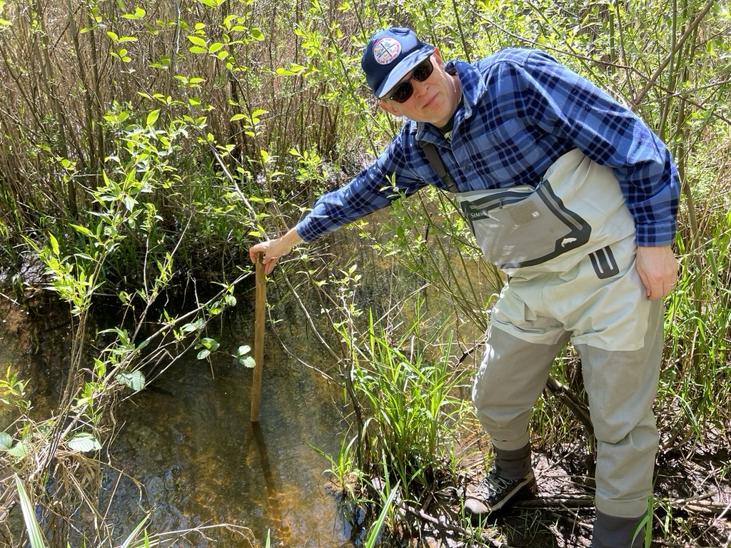

Figure 1. Paul Burns showing a deep pool in one of several narrow anabranches in a reach of Fivemile Creek restored to Stage Zero.

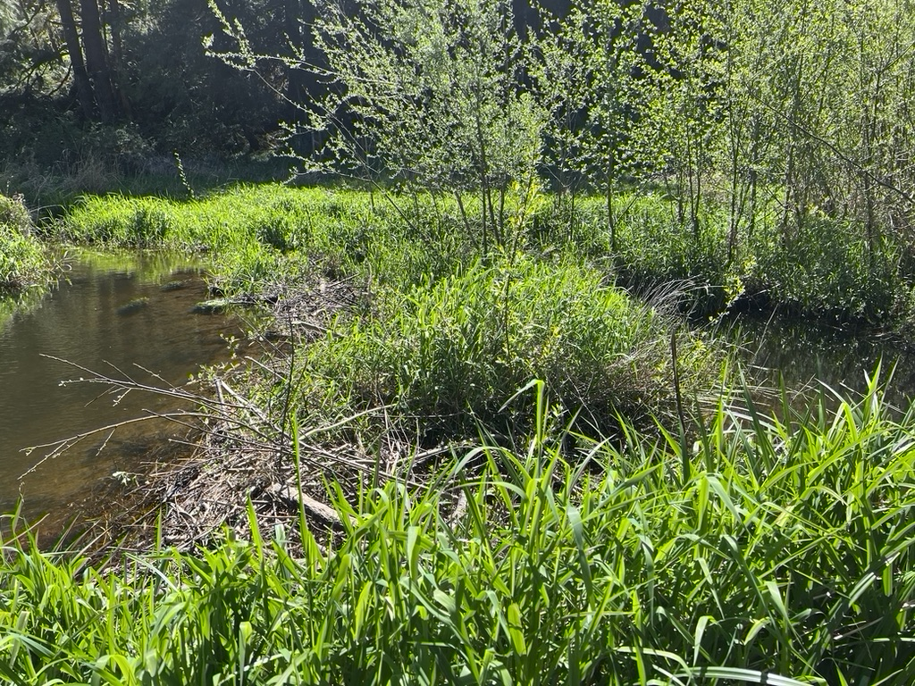

Figure 2. With the floodplain reconnected and runoff energy reduced, beavers have returned to this section of Fivemile Creek, further increasing diversity and dynamism in this low gradient stream beyond that generated by vegetation regrowth alone.

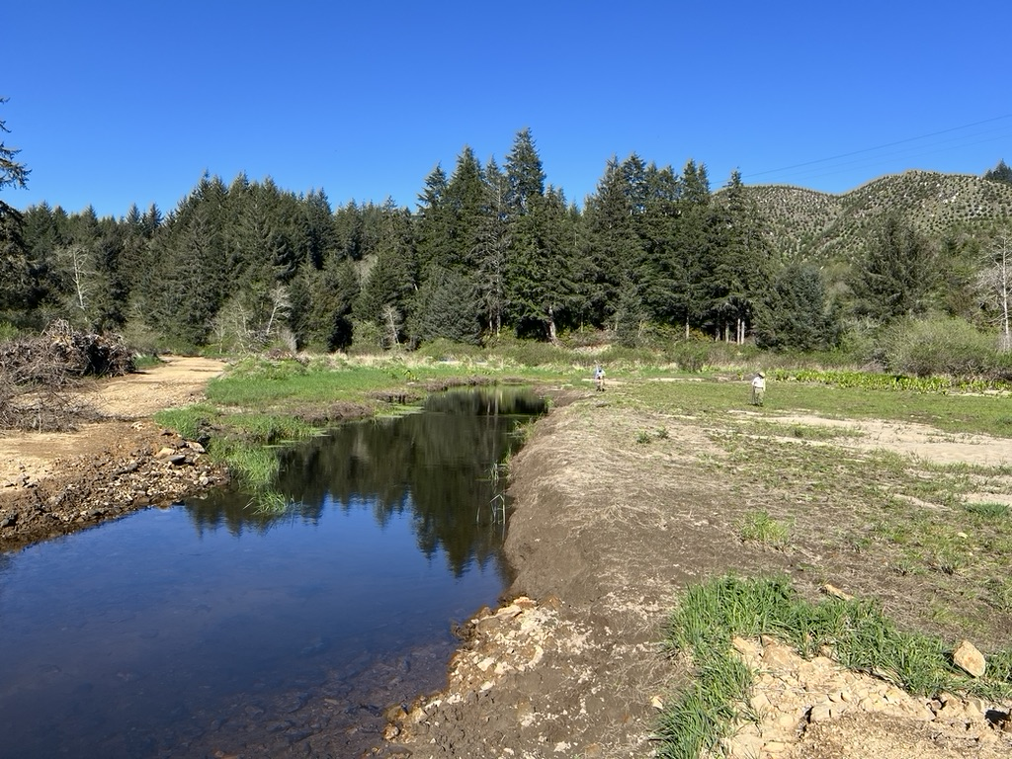

Figure 3. A ditched portion of Fivemile Creek scheduled soon to be filled with post-European legacy sediments scraped off the floodplain. Contrast this reach with the restored conditions in Figures 1 & 2.

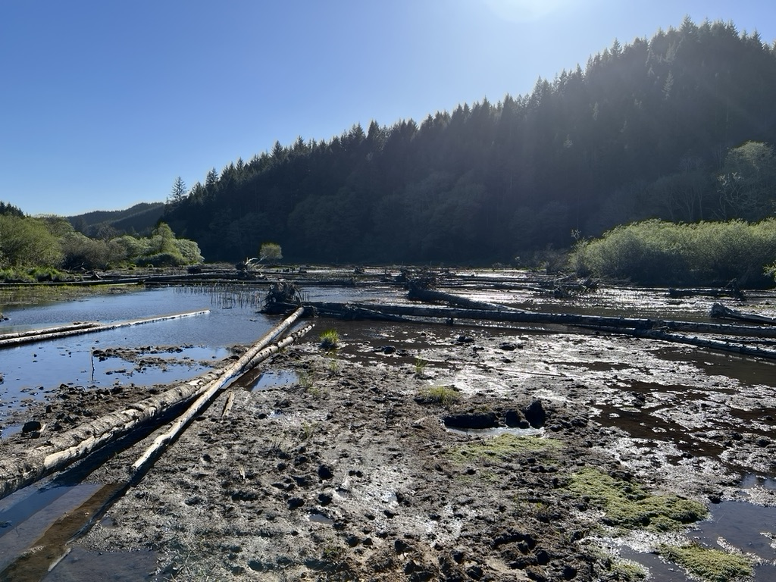

Figure 4. In this reach of Fivemile Creek, post-development alluvium has recently been removed, large wood has been placed, and vegetation re-establishment has just begun. Based on experience gained upstream, this reach will become a multi-channeled, willow ‘carr’ (i.e., a wet woodland) within a few short years.

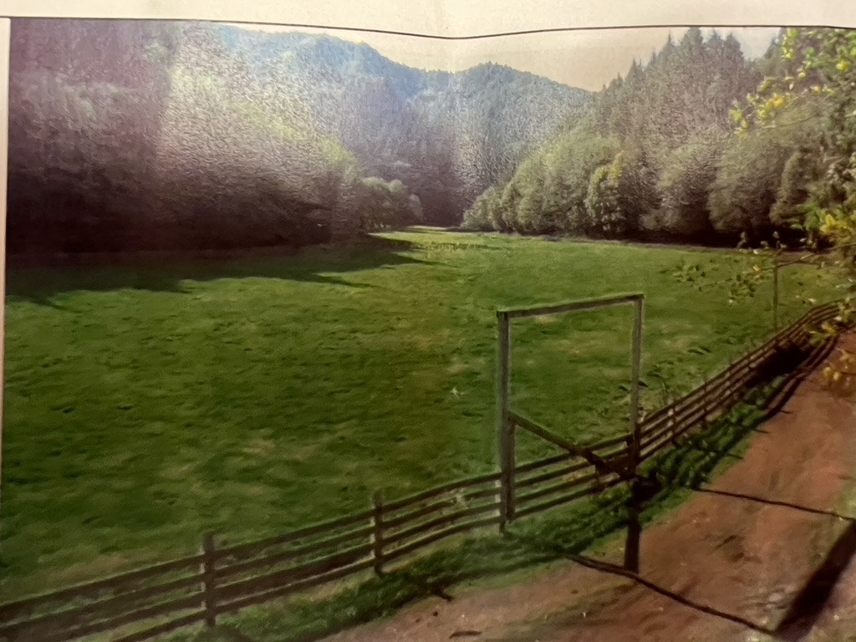

Figure 5. A pre-restoration photo. of Fivemile Creek. Prior to restoration, the creek had been channelized and moved to the far edge of the historic floodplain.

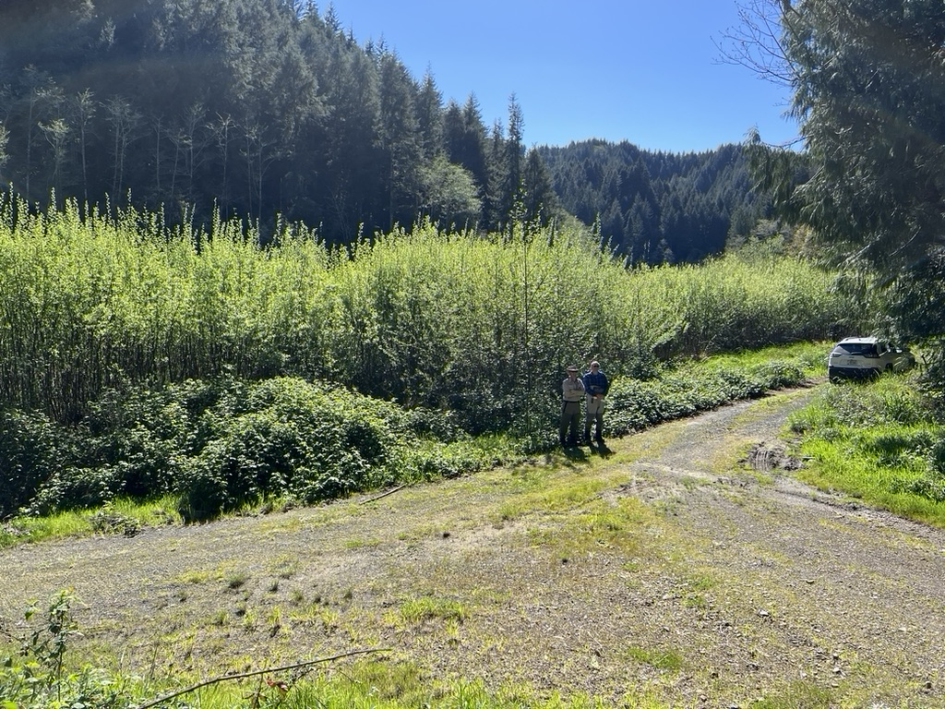

Figure 6. The same location as Figure 5, post-restoration (April 2024). The gate in the previous photo was located where Colin Thorne and Paul Burns are standing.

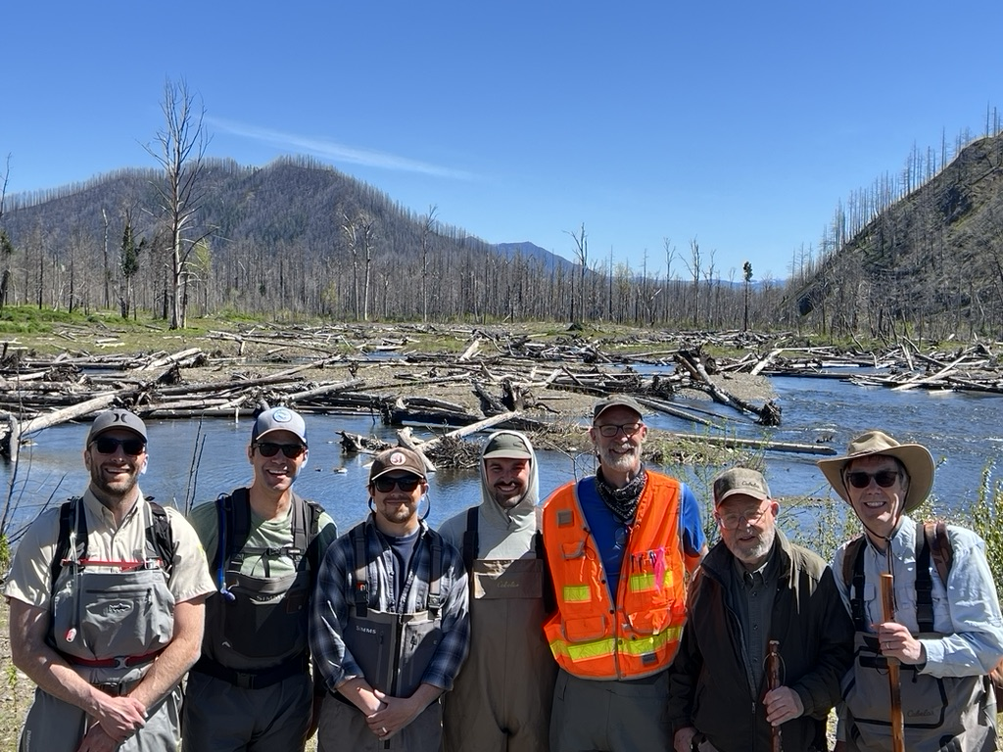

Figure 7. Several of the partners who hosted our visit to the Stage 8, reconnected floodplain on the Middle McKenzie River at Finn Rock. Note the massive amount of large wood placed in the site, and the live willow and other riparian plantings throughout the lowered and rewetted floodplain. The standing dead trees are the result of the Holiday Farm wildfire that swept through the area in 2020. Left to right: Andy Spyrka (ODFW), John Trimble (McKenzie River Trust), Logan Bodiford (USFS), Will l’Hommedieu (USACE), Johan Hogervorst (USFS), Ray White and Colin Thorne.

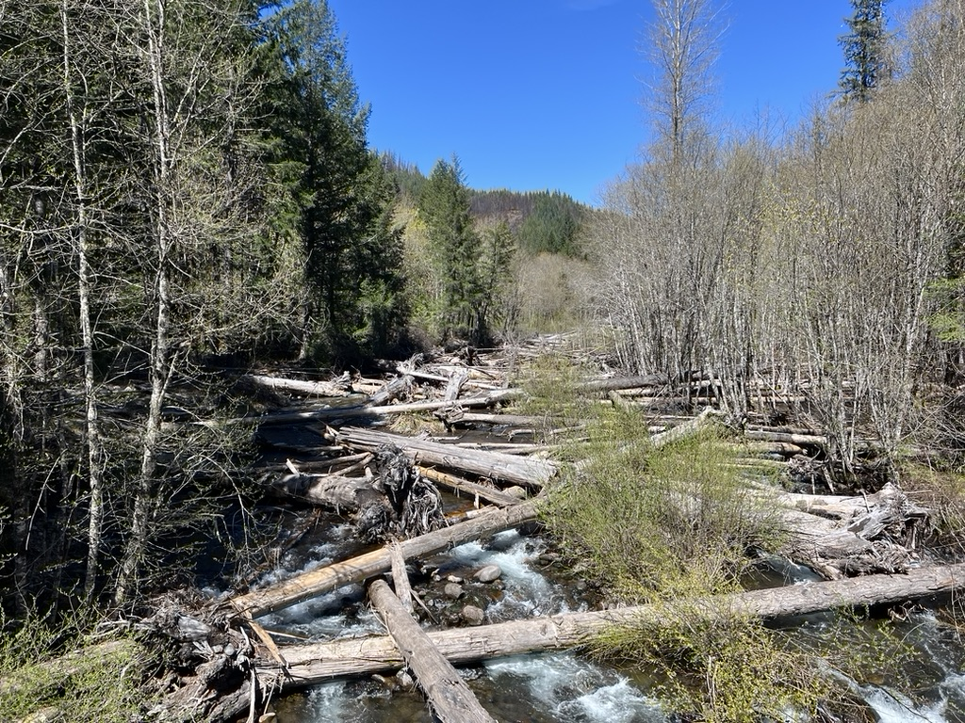

Figure 8. In Deer Creek, a very large amount of large wood has been placed to provide friction against the flashy, high energy flood flows that this steep McKenzie River tributary experiences. A good channel-floodplain system is messy, rough, and complex.

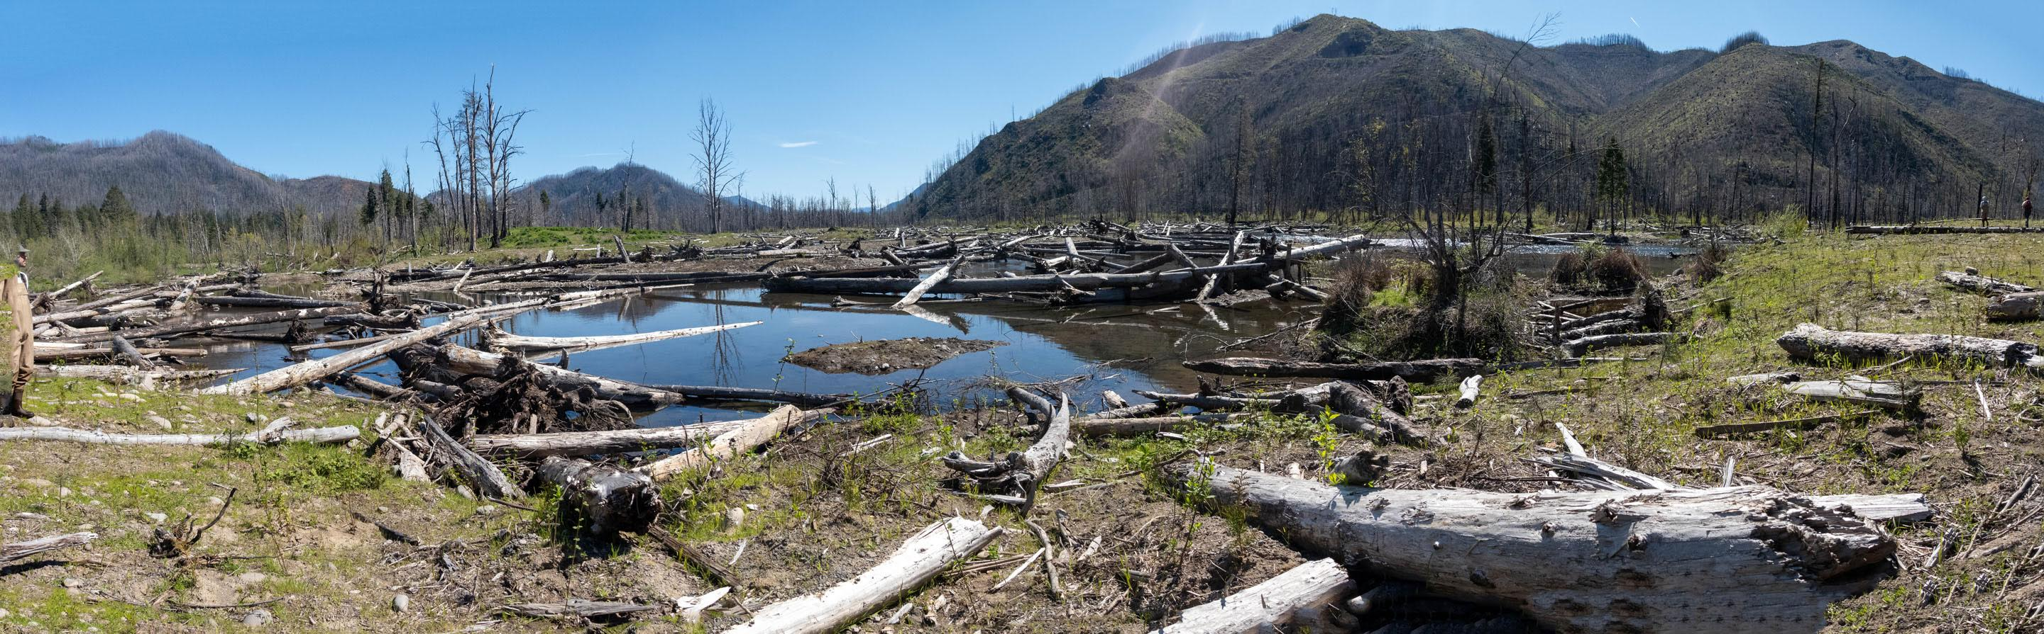

Figure 9. As illustrated here in the Finn Rock reach, the immediate result of restoration to Stages 0 or 8 using the ‘valley flood reset’ approach is a very wide and wet river-floodplain corridor.

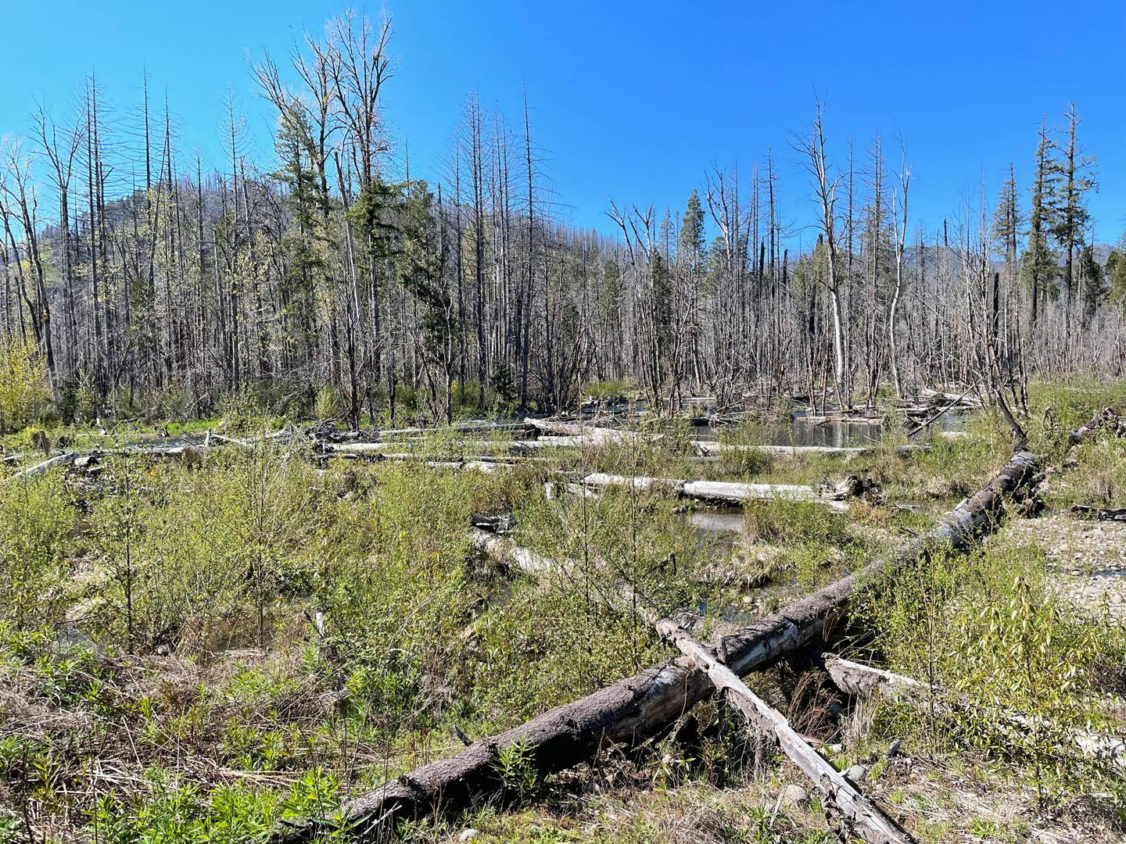

Figure 10. Willows are recolonizing the reconnected South Fork McKenzie River floodplain following the 2020 Holiday Farm wildfire.

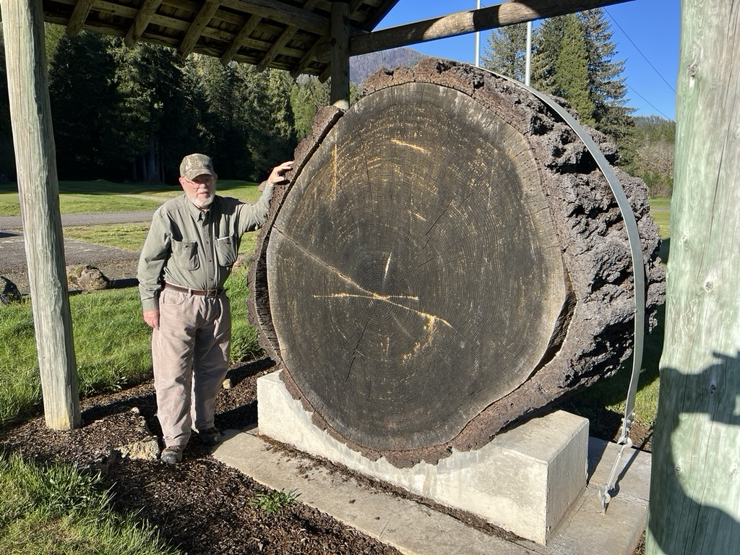

Figure 11. Ray White turned 89 years old during our tour. He put on his waders and kept up with the much younger tour guides every step of the way.

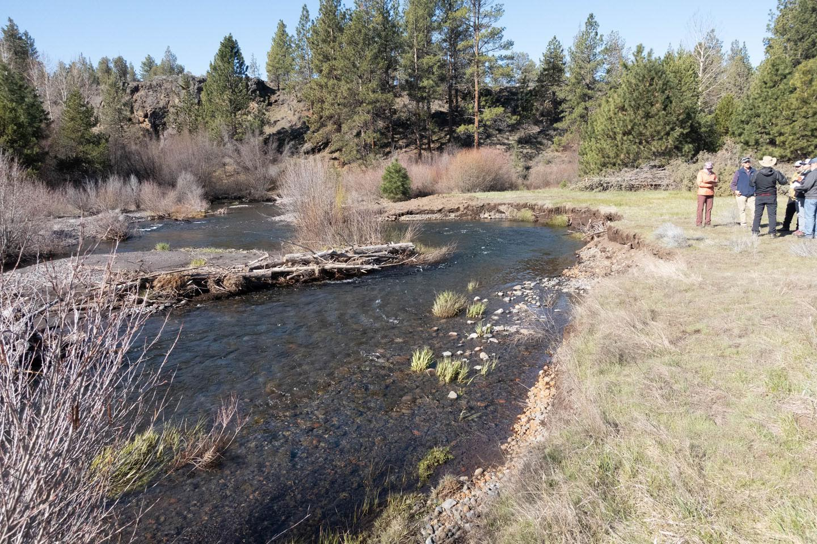

Figure 12. Post-assisted log structures (PALs) in the Willow Springs reach of Whychus Creek accelerate lateral channel migration to the right; lowering the floodplain by removing post-European settlement, legacy sediments. Note the willow growth on the left of creek, where legacy sediment removal and floodplain reconnection have already occurred.

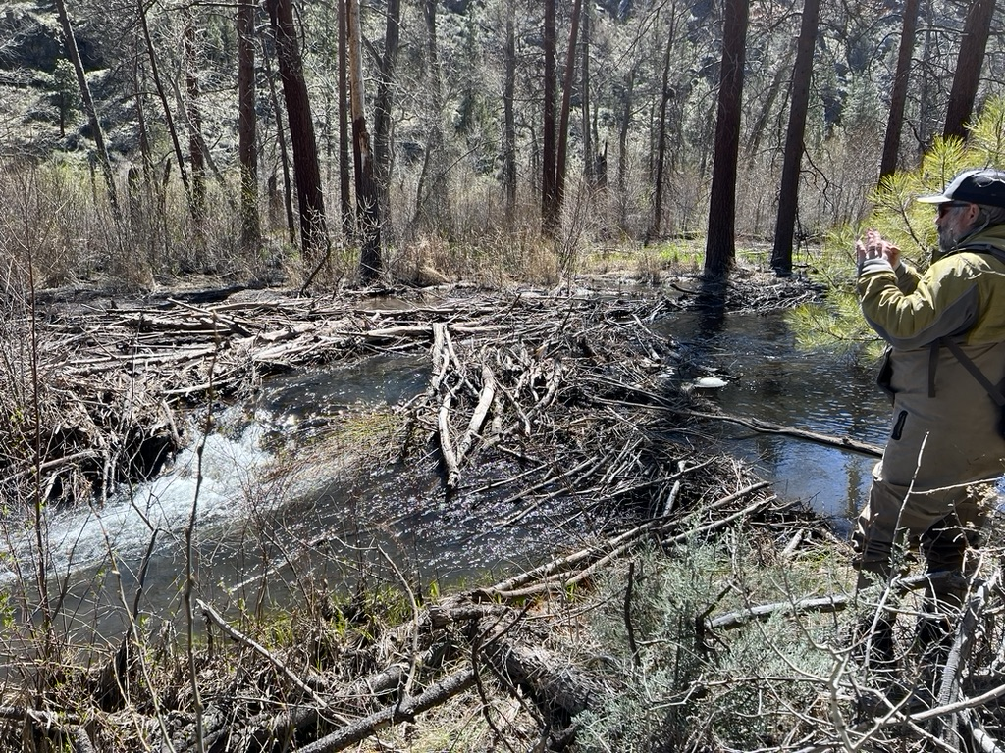

Figure 13. A new beaver dam in a reach of Whychus Creek that was restored to Stage 0 in 2016 using the ‘valley floor reset’ approach. Note the large amount of wood in the reconnected floodplain (some of which was placed and some of which has accumulated naturally) and that there is surface flow from valley wall to valley wall, even at base flow.

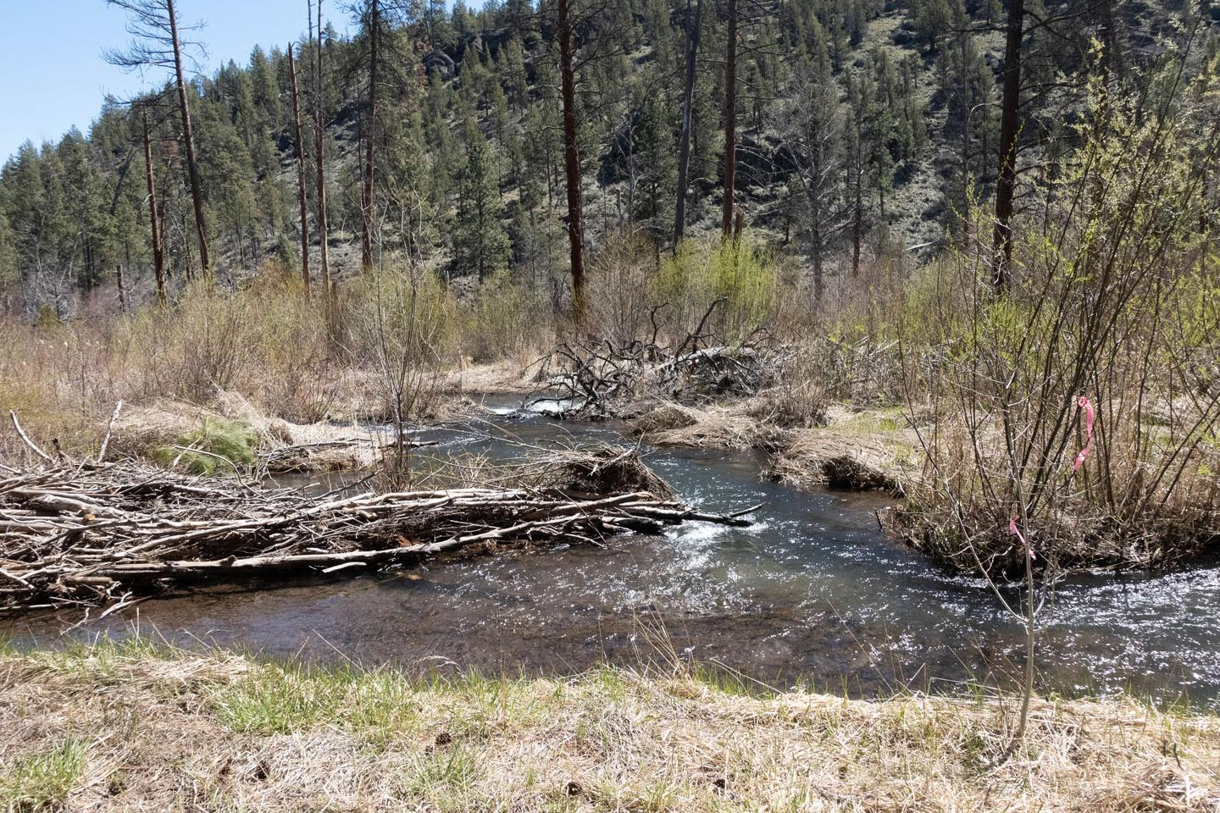

Figure 14. In the reach of Whychus Canyon Reserve restored in 2016, multiple, deep and narrow anabranches have formed within the re-wetted floodplain.

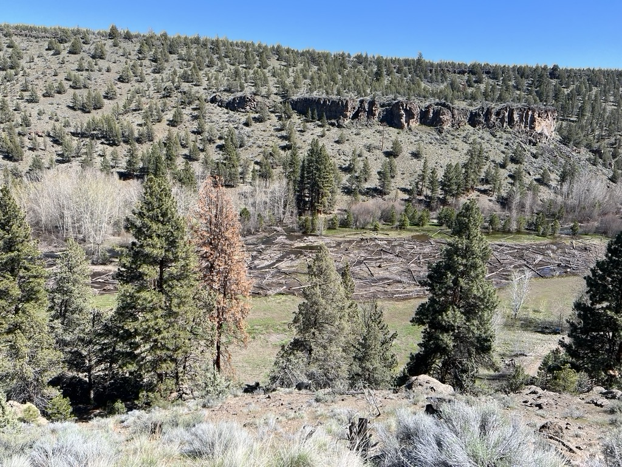

Figure 15. Rim Rock Ranch reach of Whychus Creek, which was restored using a ‘valley floor reset’ in 2023. As with other sites we visited, here post-European settlement alluvium was removed and used to fill the ditched channel. The historical floodplain is now once again fully connected to the stream at base flow. Post-project, adaptive management includes strategic placement of PALs to disperse flow through the large wood placed this site.

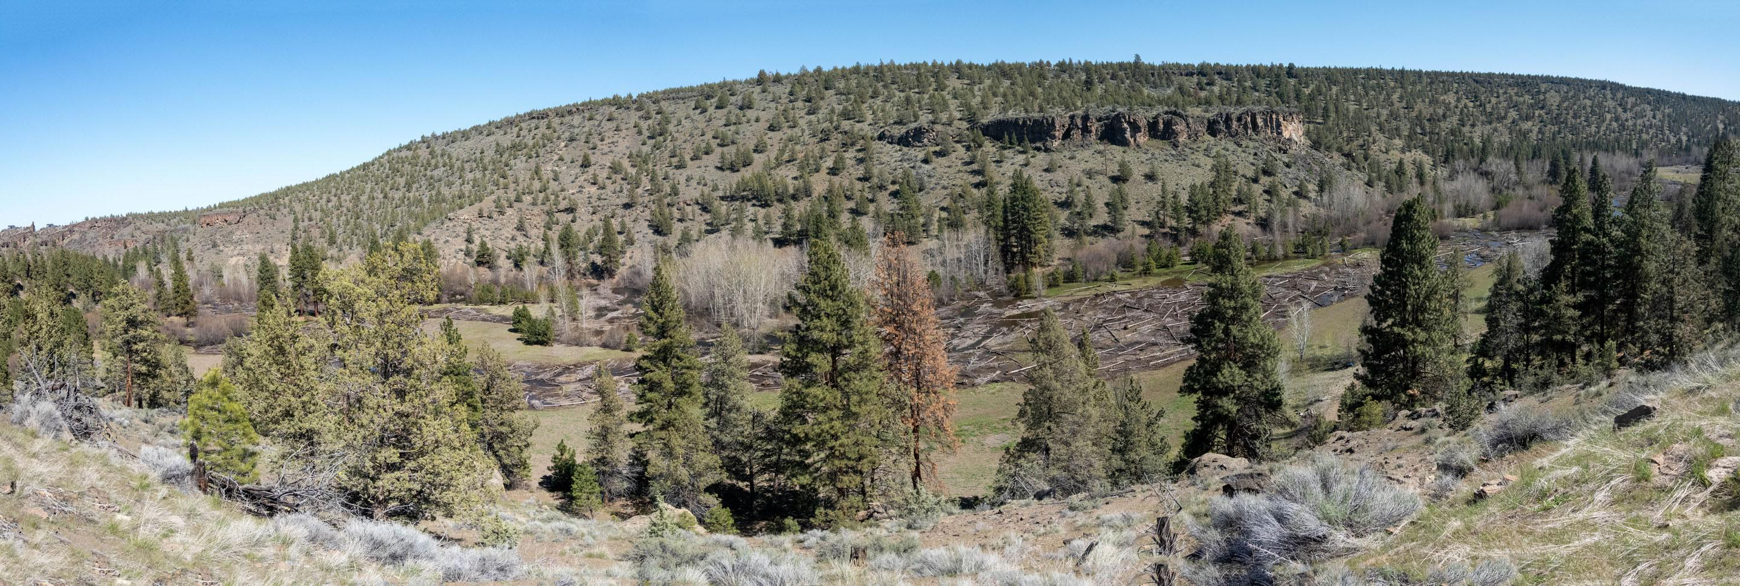

Figure 16. A panoramic view of the very large restoration site at Rim Rock Ranch.

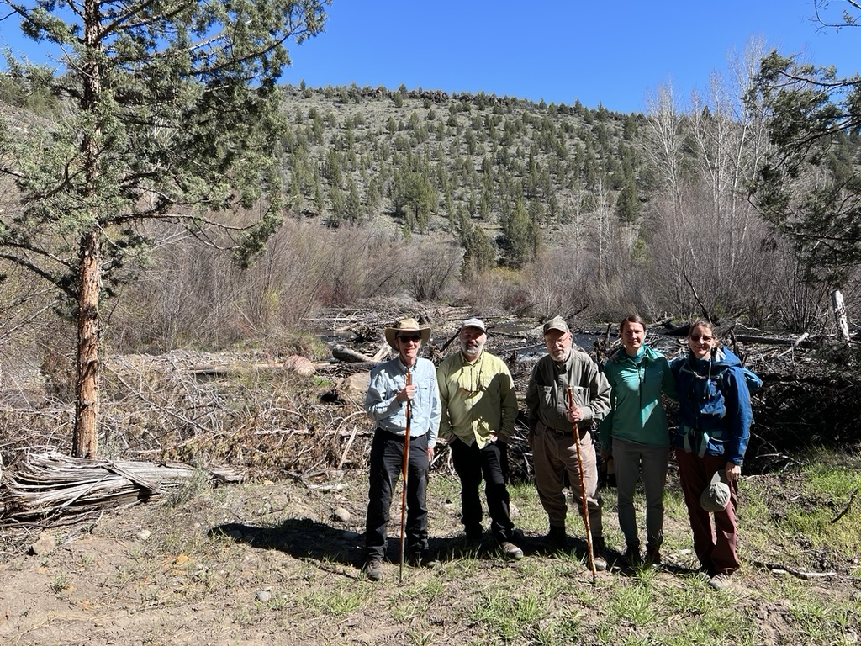

Figure 17. Partners and visitors in front of an extensive engineered log jam at the downstream termination of the Rim Rock Ranch project reach of Whychus Creek. This is the location of a natural geomorphic control, but nevertheless an extensive engineered log jam has been installed to ensure that no head cuts move into the restored reach from the unrestored, incised drainage system downstream. Left to right: Colin Thorne, Casey Schuder (Upper Deschutes Watershed Council), Ray White, Lauren Mork (UDWC), and Karen Allen (Aequinox Designing with Nature).

**About the contributors to this blog posting:**

**Ray White**

Ray White (BA, MS, PhD Zoology, University of Wisconsin-Madison), is a stream ecologist and fishery biologist. He served as a Wisconsin Dept. of Natural Resources (WDNR) researcher evaluating trout habitat management 1957-1972, with leave for work in Germany and Austria. His 1967 guidelines bulletin on such management (now partly outdated) has long been used nationally and internationally. He taught fishery science at Michigan State and Montana State Universities during 1972-1990, thereafter working as a stream restoration consultant. Semi-retired and living near Seattle, he often travels to his Wisconsin, creek side cabin, which serves as a base for organizing, since 2013, an annual trout stream restoration workshop for WDNR biologists and technicians, as well as personnel from other agencies and NGOs. The workshop emphasizes the role of natural processes in stream self-healing from anthropogenic harm, especially the roles of riparian vegetation. Workshop speakers include the nation’s experts on stream ecology and geomorphology.

**Tracy Hames**

Tracy obtained his BA in Biology and Environmental Studies from Macalester College in 1984, and his MS in Natural Resources from the University of Wisconsin – Stevens Point, in 1990.

In 1989 he moved to central Washington state to work as a Waterfowl and Wetlands Biologist for the Yakama Nation, where he stayed for 22 years. At Yakama he built a large wetland and floodplain protection and restoration project in the irrigated agricultural valley of the Reservation. This project, located in two of the most productive steelhead-producing watersheds in the Yakima River Basin, made use of the cultures and traditions of the Yakama People along with science-based techniques to produce an approach to restoration combining traditional knowledge and ecological concepts. Encompassing over 22,000 acres and hundreds of river/creek miles, this project emphasized the restoration of historic conditions in an incredibly disturbed landscape. Restoration activities targeted floodplains, river and creek channels, wetlands, riparian forests, and grasslands. Beavers were an important partner in the management of these restored floodplains, which demonstrate the advantages of restoring channel-floodplain connectivity, but pre-date conceptualization of Stages 0 or 8 in the SEM.

A Midwesterner at heart, Tracy moved back to Wisconsin in 2012 to take the position of Executive Director with Wisconsin Wetlands Association. In this position, he works across the state to help communities understand how wetlands can be solutions to the habitat, water quality, flooding, and other issues they face.

**About Wisconsin Wetlands Association**

WWA is a non-partisan, science-based, statewide NGO, dedicated to the protection, restoration, and enjoyment of Wisconsin’s wetlands. We envision a state where wetlands are healthy, plentiful, and support ecological and societal needs, and where citizens care for, appreciate, and interact with these natural treasures.